**Login Form**

**Admin Dashboard**

* Number of Fishing Market
* Number of Fisherman
* Total Catch Information (in kilogram)
* Number of City
* Number of Province

**City Information**

* City name
* Province name

**Province Information**

* Province name

**Fishing Market Information**

* Market name
* About the market
* City
* Province

**Fisherman Information**

* First name
* Middle name
* Last name
* Province
* City
* Complete address
* Contact
* Username
* Password
* Account Status

**Fisherman Vessel Information**

* Vessel name
* Description
* Fisherman owner
* Image

**Catch Record Information**

* Date
* Time
* Fisherman Complete name
* Vessel name
* Fish name
* Catch in Kilogram
* Fishing Location – View Map
* Dispatch to (Fishing Market)

**User Management**

* First name
* Middle name
* Last name
* Designation
* Province
* City
* Complete address
* Contact
* Email Address
* Username
* Password
* Account Status

**Catch Report by Month**

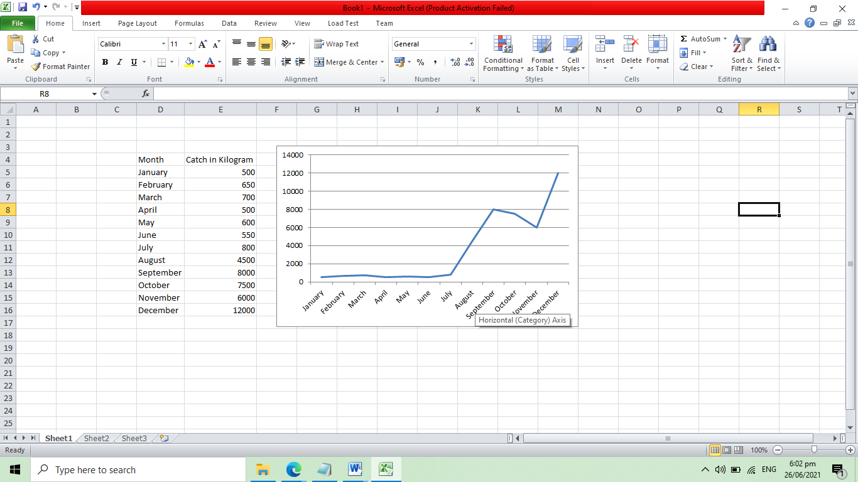

**Catch Report by Fish**

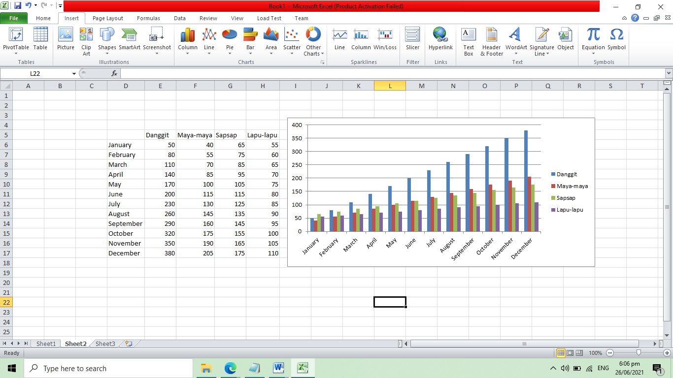

**Database Backup Form**

**Fisherman Account**

**Fisherman Dashboard**

* Total Catch Information (in kilogram)
* **List of Fishes Catches**

|  |  |
| --- | --- |
| Fish name | Catch in KG |
| Danggit | 50 |
| Maya-maya | 67 |
| Sapsap | 65 |
| Lapu-lapu | 45 |

**Record Fish Catch**

* Date
* Time
* Vessel name
* Fish name
* Catch in Kilogram
* Fishing Location – View Map
* Dispatch to (Fishing Market)